**23CSE111**

**OBJECT-ORIENTED PROGRAMMING**

**LAB REPORT**



**Department of Computer Science Engineering**

**Amrita School of Computing**

**Amrita Vishwa Vidyapeetham, Amaravati Campus**

**Name: T. Kushal**

**Verified By: Roll No: 24333**

**WEEK-1**

**1) Explain the process of Installing JDK (Java Development Kit)**

**Installing of JDK (Java Development Kit):**

1. **Download JDK:**
   * Go to the Oracle JDK download page in your web browser and click on the JDK-21 version which is the long-term support (LTS) version.
   * Click on the download link for your operating system (Windows, macOS, or Linux).
2. **Install JDK:**
   * Once downloaded, run the installer.
   * Follow the instructions and click "Next" until it's done.
3. **Set Environment Variables (Windows):**
   * Open File Explorer, then right-click on This PC next select properties then it will take you to the settings app click on Advanced System Settings and then  
     Click on **Environment Variables**.
   * Click **New** under **System Variables**:
     + **Set Variable name as:** java home
     + **Variable value:** The folder address where JDK is installed (like C:\Program Files\Java\jdk-21\bin)

Find Path under **System Variables**, click **Edit**, and add the path of the jdk-21(C:\Program Files\Java\jdk-21\bin)

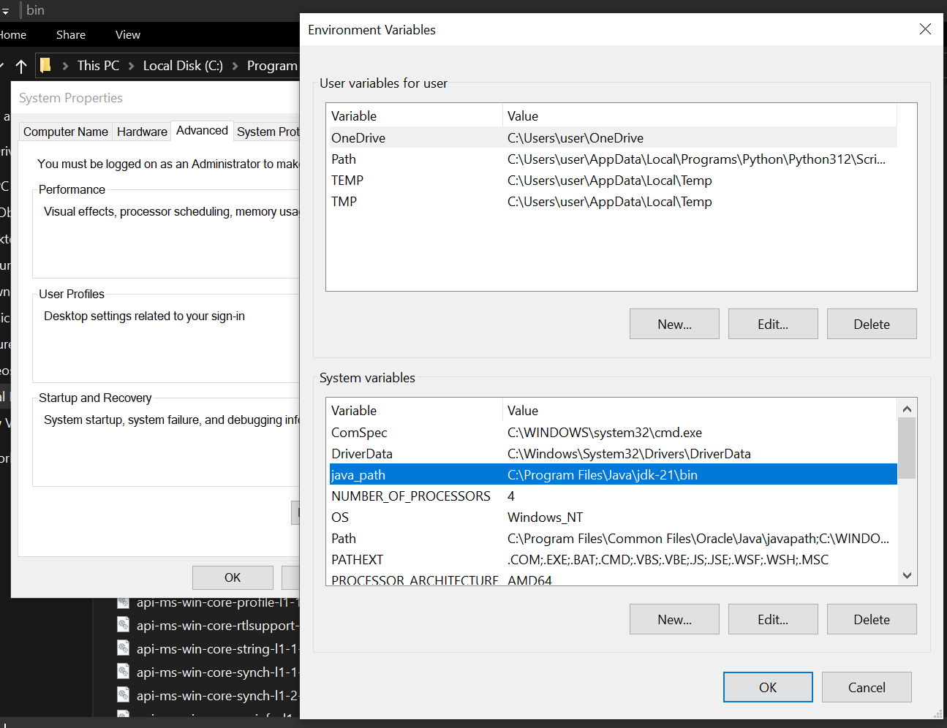

**Checking of JDK Version:**

1. **Open Command Prompt:**
   * Press win+R, type cmd, and press Enter.
2. **Check Version:**
   * Type java --version and press Enter.
   * Type javac --version and press Enter.

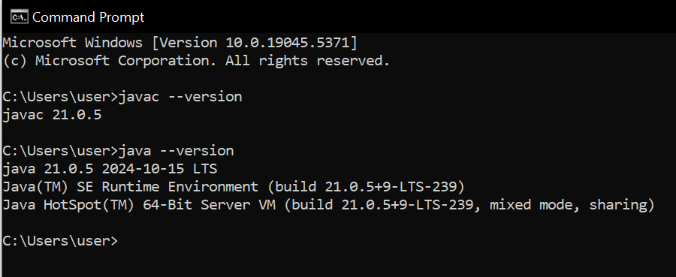

**2) Simple Java Program for printing the Name, Class, and Roll No, of a student**

**CODE:**

class Main

{

public static void main (String [] args)

{

System.out.println("Name: T.Kushal");

System.out.println("Section: CSE-C");

System.out.println("Roll No: 24333");

}

}

**Output:**

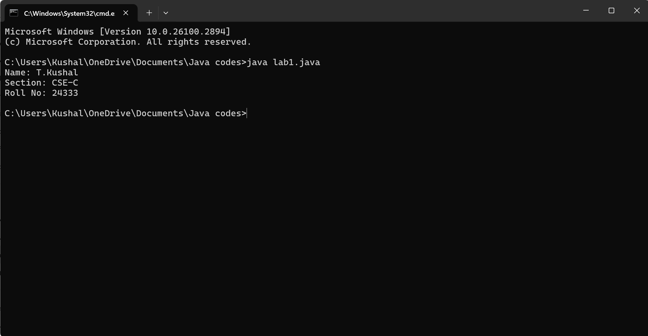

**WEEK-2**

1**) Write a Java program to find S.I.**

**Code:**

public class SimpleInterestCalculator {

     public static void main(String[] args) {

        try (java.util.Scanner scanner = new java.util.Scanner(System.in)) {

            System.out.print("Enter the principal amount (in rupees): ");

            double principal = scanner.nextDouble();

            System.out.print("Enter the annual interest rate (in %): ");

            double rate = scanner.nextDouble();

            System.out.print("Enter the time period (in years): ");

            int time = scanner.nextInt();

            double simpleInterest = (principal * rate * time) / 100;

            System.out.println("Simple Interest: ₹" + simpleInterest);

        }

    }

}

**Output:**

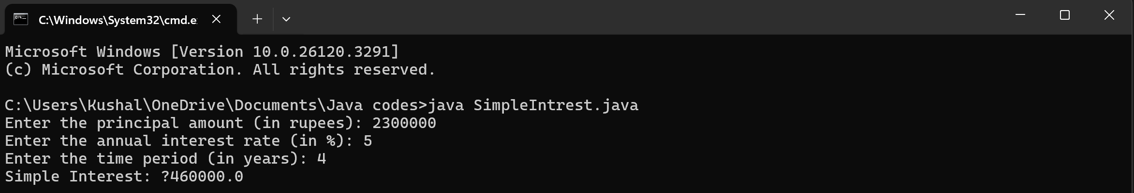

**Error:**

|  |  |  |
| --- | --- | --- |
| **SI.NO** | **ERROR MESSAGE** | **ERROR RECTIFICATION** |
| **1**. |  |  |
| **2**. | error: can't find primary (String []) method in class: SimpleInterestCalculator | Should close the string brackets [] |

**Important Points:**

* Used Scanner library to get input from user in run time.

Import java. Util. Scanner;”-step to import library.

* Scanner input= new Scanner (System.in);”-step to use the scanner. [case sensitive]
* Should give the ‘;’ symbol at the end of System.out.print("Enter the rate of interest (R) in percentage: ").

**2**) **Write a program on Java on the Factorial of a number with inputs taken.**

**Code:**

Import java.util.Scanner;

public class Factorialofanumber {

public static void main(String[] args) {

Scanner scanner = new Scanner(System.in);

System. out.print("Enter the number: ");

int number = scanner.next();

long factorial = 1;

if (number < 0) {

System. out.println("No Factorial For Negative Numbers.");

} else {

for (int i = 1; i <= number; i++) {

factorial *=i;

}

System.out.println("The factorial of " + number + " is " + factorial);

}

scanner.close();

}

}

**Output:**

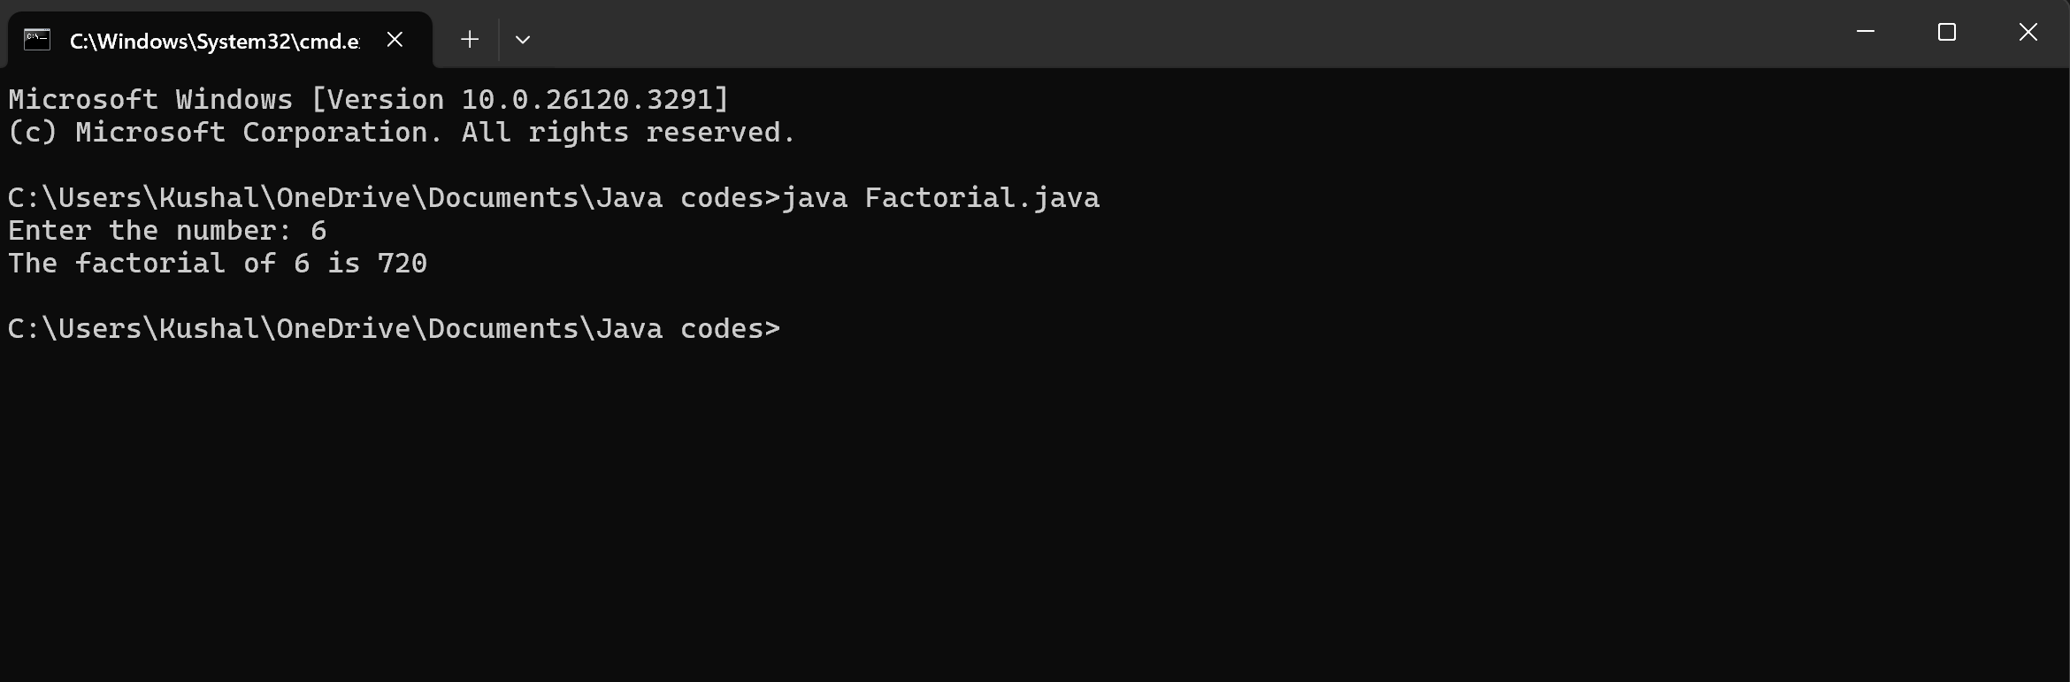

**Error:**

|  |  |  |
| --- | --- | --- |
| **SI.NO** | **ERROR MESSAGE** | **ERROR RECTIFICATION** |
| 1. |  |  |
| 2. |  |  |

**Important Points:**

* In the loop, the expression factorial*i; is incorrect because the result of the multiplication is not assigned back to factorial. It should be factorial*i; for proper multiplication and assignment.
* **Using a colon** after it will cause a syntax error.
* **Curly braces** {} are used to group the code inside the if block.

3) Write a Java program to convert the Temperature from Celsius to Fahrenheit & Fahrenheit to Celsius.

**CODE FOR CELSIUS TO FAHRENHEIT:**

Import java.util.Scanner;

public class CelsiustoFahrenheit {

public static void main(String[] args) {

Scanner scanner = new Scanner(System.in);

System. out.print("Enter temperature in Celsius: ");

float celsius = scanner.nextFloat();

float Fahrenheit = (celsius * 9 / 5) + 32;

System.out.println(celsius + "°C is equal to " + Fahrenheit + "°F");

scanner.close();

}

}

**Output:**

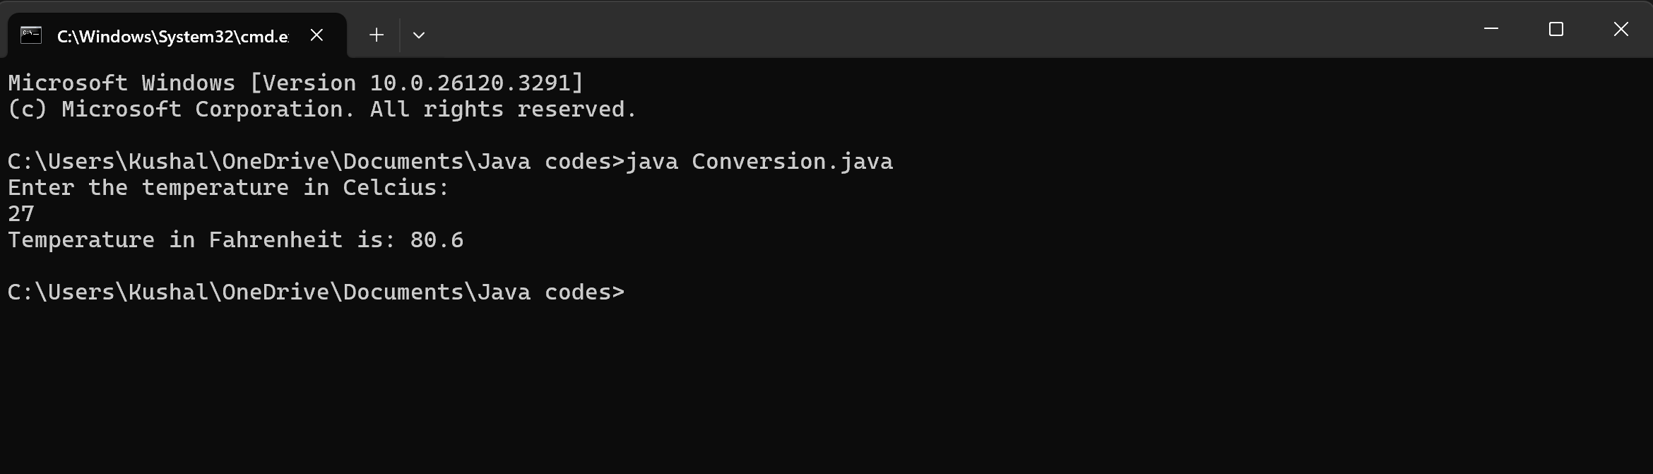

**Error:**

|  |  |  |
| --- | --- | --- |
| **SI.NO** | **ERROR MESSAGE** | **ERROR RECTIFICATION** |
| 1. |  |  |
| 2. | Duplicate close of scanner- scanner.close(); scanner.close() Reason: Use only one scanner.close(); | Duplicate close of scanner- scanner.close(); scanner.close() Reason: Use only one scanner.close(); |

**Important Points:**

* In the line float Fahrenheit=Celsius * 9 / 5 + 32; the formula does not have proper parentheses for the multiplication and division. It should be float Fahrenheit = (Celsius * 9 / 5) + 32; for the correct order of operations.
* In the System.out.println() statement, there is a missing semicolon at the end of the line.

**CODE FOR FAHRENHEIT TO CELSIUS:**

Import java.util.Scanner;

public class FahrenheittoCelsius {

public static void main(String[] args) {

Scanner scanner = new Scanner(System.in);

System. out.print("Enter Fahrenheit temp: ");

float f = scanner.nextFloat();

float celsius = (f - 32) * 5 / 9;

System.out.println(f + "°F is equal to " + celsius + "°C");

scanner.close();

}

}

**Output:**

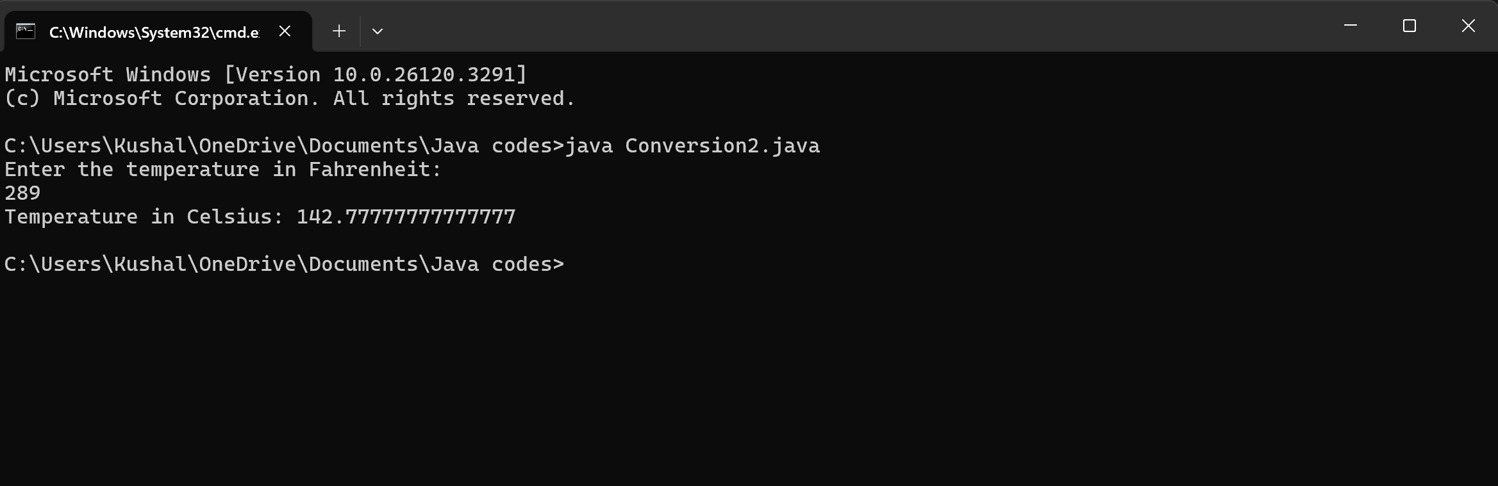

**Error:**

|  |  |  |
| --- | --- | --- |
| **SI.NO** | **ERROR MESSAGE** | **ERROR RECTIFICATION** |
| 1. |  |  |
| 2. |  |  |

**Important points:**

* The System.out.println statement is using Celsius with a capital "C" which doesn't exist as a variable. Java is case-sensitive, so this will cause a compilation error. It should be lowercase Celsius.
* The scanner.close() method is called twice, which is unnecessary and could cause issues. It should only be called once.

**4. Write a Program on the Fibonacci sequence where input is taken from the user.**

**CODE:**

public class FibonacciSeries {

public static void main(String[] args) {

int n = 10;

int firstTerm = 0, secondTerm = 1;

System.out.println("Fibonacci Series up to " + n + " terms:");

for (int i = 1; i <= n; ++i) {

System.out.print(firstTerm + ", ");

int nextTerm = firstTerm + secondTerm;

firstTerm = secondTerm;

secondTerm = nextTerm;

}

}

}

**Output:**

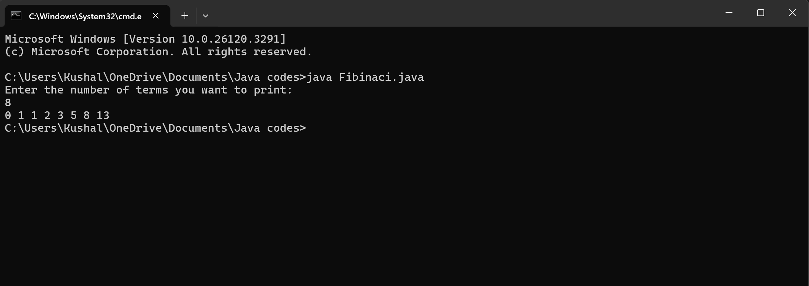

**Error:**

|  |  |  |
| --- | --- | --- |
| **SI.NO** | **ERROR MESSAGE** | **ERROR RECTIFICATION** |
| 1. | int[] fibonacci = new int[n]; System.out.println(fibonacci[n + 1]); invalid access replace: System.out.println("Fibonacci Series up to " + n + " terms:"); | int[] fibonacci = new int[n]; System.out.println(fibonacci[n + 1]); invalid access replace: System.out.println("Fibonacci Series up to " + n + " terms:"); |
| 2. | error: can't find primary (String []) method in class: SimpleInterestCalculator | Should close the string brackets [] |

**IMPORTANT POINTS:**

* Variables should be initialized properly
* Accessing an array element outside its bounds.
* Loop condition should be properly defined. No syntax error should be there.

**5. Write a program with Java on How to calculate the Area of the Rectangle & Area of the Triangle.**

**CODE FOR CALCULATING THE AREA OF THE RECTANGLE:**

Import java.util.Scanner;

public class Rectangle area {

public static void main(String[] args) {

Scanner scanner = new Scanner(System.in);

System. out.print("Enter the length of the rectangle: ");

double length = scanner.nextDouble();

System. out.print("Enter the width of the rectangle: ");

double width = scanner.nextDouble();

double area = length * width;

System. out.println("The area of the rectangle is: " + area);

}

}

**Output:**

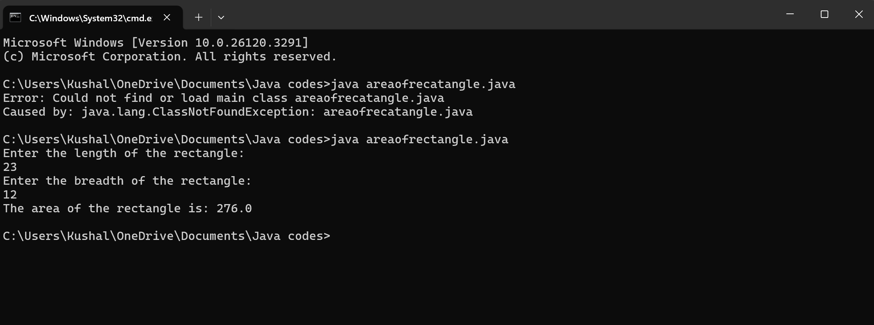

**Error:**

|  |  |  |
| --- | --- | --- |
| **SI.NO** | **ERROR MESSAGE** | **ERROR RECTIFICATION** |
| 1. |  |  |
| 2. |  |  |

**Important points:**

* Trying to assign a double value to an int variable.
* Incorrect placement of braces, should be placed correctly.
* Should not give incorrect variables.

**CODE FOR CALCULATING THE AREA OF THE TRIANGLE:**

Import java.util.Scanner;

public class heronstriangle {

public static void main(String[] args) {

Scanner scanner = new Scanner(System.in);

// Taking input from the user

System. out.print("Enter the length of side a: ");

double a = scanner.nextDouble();

System. out.print("Enter the length of side b: ");

double b = scanner.nextDouble();

System. out.print("Enter the length of side c: ");

double c = scanner.nextDouble();

// Calculate the semi-perimeter

doubles = (a + b + c) / 2;

// Calculate the area using Heron's Formula

double area = Math.sqrt(s * (s - a) * (s - b) * (s - c));

// Print the result

System. out.println("The area of the triangle is: " + area);

scanner.close();

}

}

**Output:**

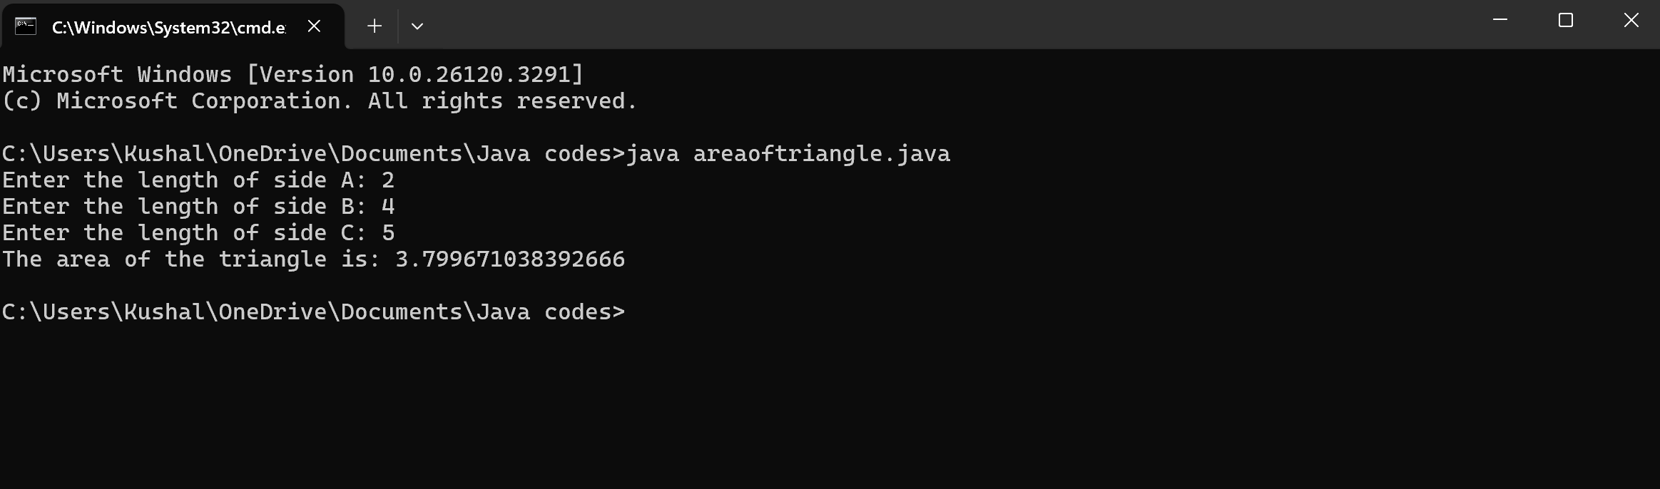

**Error:**

|  |  |  |
| --- | --- | --- |
| **SI.NO** | **ERROR MESSAGE** | **ERROR RECTIFICATION** |
| 1. |  |  |
| 2. | error: can't find primary (String []) method in class: SimpleInterestCalculator | Should close the string brackets [] |

**Important points:**

* Verify that the input values can form a valid triangle (i.e., the sum of any two sides must be greater than the third side).
* Calculate the semi-perimeter ss using the formula: s=a+b+c/2.

**WEEK-3**

1. To create a Java program with the following:

a) Create a class with the name car

b) Create four attributes named Car_colour, Car_brand, Fuel_type, mileage

c) Create three methods named Strat (), Stop (), Service ()

d) Create three objects named Car1, Car2, Car3.

**CODE FOR CREATING CAR CLASS**

class car

{

    public String car_color;

    public String car_brand;

    public String fuel_type;

    public float mileage;

    public void start()

    {

        System.out.println("Car starts");

    }

    public void stop()

    {

        System.out.println("Car stops");

    }

    public void service()

    {

        System.out.println("Car service");

    }

    public static void main(String [] args){

            car car1= new car();

            car1.car_color="Red";

            car1.car_brand="BMW";

            car1.fuel_type="Petrol";

            car1.mileage=56.7F;

            car1.start();

            car1.stop();

            car1.service();

            System.out.println("color of the car1 is "+car1.car_color);

            System.out.println("brand of the car1 is "+car1.car_brand);

            System.out.println("fuel type of the car1 is "+car1.fuel_type);

            System.out.println("mileage of the car1 is"+car1.mileage);

            car car2= new car();

            car2.car_color="Blue";

            car2.car_brand="Mahindra";

            car2.fuel_type="Hybrid";

            car2.mileage=60.5F;

            car2.start();

            car2.stop();

            car2.service();

            System.out.println("color of the car2 is "+car2.car_color);

            System.out.println("brand of the car2 is "+car2.car_brand);

            System.out.println("fuel type of the car2 is "+car2.fuel_type);

            System.out.println("mileage of the car2 is"+car2.mileage);

            car car3= new car();

            car3.car_color="Yellow";

            car3.car_brand=" Mercedes";

            car3.fuel_type="Diesel";

            car3.mileage=66.5F;

            car3.start();

            car3.stop();

            car3.service();

            System.out.println("color of the car3 is "+car3.car_color);

            System.out.println("brand of the car3 is "+car3.car_brand);

            System.out.println("fuel type of the car3 is "+car3.fuel_type);

            System.out.println("mileage of the car3 is"+car3.mileage);

    }

}

**Output:**

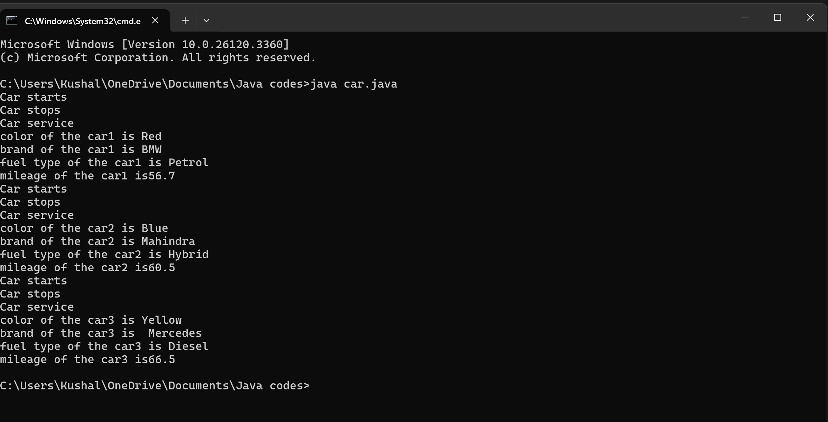

**Error:**

|  |  |  |
| --- | --- | --- |
| **SI.NO** | **ERROR MESSAGE** | **ERROR RECTIFICATION** |
| 1. |  |  |
| 2. | error: can't find primary (String []) method in class: SimpleInterestCalculator | Should close the string brackets [] |

**Important points:**

* Variable name mismatch: The variable car_Color in the code should be car_color
* Incorrect variable name: car1.car_color is used when the actual variable is car1.car_Color, which will cause an error due to case sensitivity.
* Missing Semicolon: Forgetting to add a semicolon at the end of a statement will cause a compilation error.

**2. To create a class Bank Account with Methods deposit () and Withdrawal ()**

CODE:

Import java.util.Scanner;

class BankAccount {

    private float existing;

    private Scanner input;

    public BankAccount() {

        input = new Scanner(System.in);

        System. out.print("Enter existing amount in bank account: ");

        this.existing = input.nextFloat();

    }

    public void deposit() {

        System.out.print("Enter amount to be deposited: ");

        float deposit = input.nextFloat();

        existing += deposit;

        System.out.println("Existing amount now is: " + existing);

    }

    public void withdrawal() {

        System.out.print("Enter amount to be withdrawn: ");

        float withdrawal = input.nextFloat();

        if (existing < withdrawal) {

            System.out.println("Not sufficient balance.");

        } else {

            existing -= withdrawal;

            System.out.println("Remaining balance: " + existing);

        }

    }

    public static void main(String[] args) {

        BankAccount customer1 = new BankAccount();

        customer1.deposit();

        customer1.withdrawal();

    }

}

**Output:**

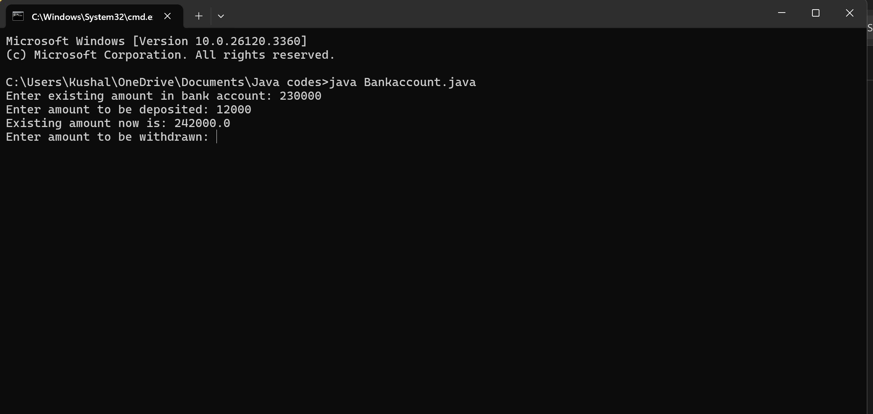

**Error:**

|  |  |  |
| --- | --- | --- |
| **SI.NO** | **ERROR MESSAGE** | **ERROR RECTIFICATION** |
| 1. |  |  |
| 2. |  |  |

**Important points:**

* **The balance should be a float or double to handle decimal values correctly, but it's declared as an int.**
* **Incorrect deposit method signature: The method DEPOSIT () has an incorrect return type int(), while it should be void since it doesn't need to return any value.**
* **Fixed the return type of deposit: Changed from int to void, as the method does not need to return anything**

**WEEK-4**

**1. Write a Java program with a class named Book**

**a) a class should contain various attributes such as title, author, and year of publication.**

**b) it should also contain a constructor with parameters which initialize the title, author, and year of publication.**

**c)create a method which displays the details of the book title, author, year of publication**

**Display the details of two books.**

CODE:

class Book {

public String book title;

public String book author;

public int bookYearOfPublication;

public void title() {

System.out.println("Book Title");

}

public void author() {

System.out.println("Book Year of Publishing")

}

public static void main(String[] args) {

Book book1 = new Book();

book1.bookTitle = "Harry potter and the philosopher stone";

book1.bookAuthor = "J.K.Rowling";

book1.bookYearOfPublication = 1997;

book1.title();

book1.author();

System.out.println("Book title is: " + book1.bookTitle);

System.out.println("Book author is: " + book1.bookAuthor);

System.out.println("Book year of publication is: " + book1.bookYearOfPublication);

Book book2 = new Book();

book2.bookTitle = "Sherlock homes";

book2.bookAuthor = "Sir Arthur Conan Doyle";

book2.bookYearOfPublication = 1892;

book2.title();

book2.author();

System.out.println("Book title is: " + book2.bookTitle);

System.out.println("Book author is: " + book2.bookAuthor);

System.out.println("Book year of publication is: " + book2.bookYearOfPublication);

}

}

**Output:**

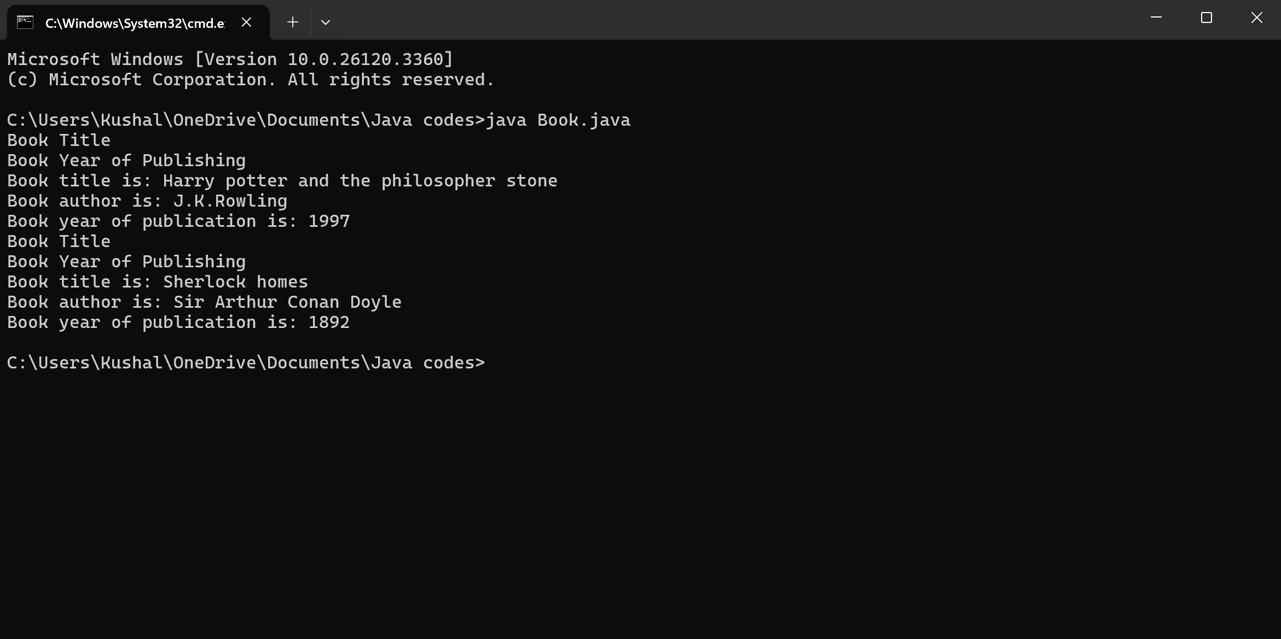

**Error:**

|  |  |  |
| --- | --- | --- |
| **SI.NO** | **ERROR MESSAGE** | **ERROR RECTIFICATION** |
| 1. |  |  |
| 2. |  |  |

**Important points:**

**2. Create a Java program with a class named ‘MyClass’ with a static variable count of int type, initialized to zero and a constant variable ‘pi’ or type double initialized to 3.14 as attributes of the class. Now define a constructor for “MyClass” that increments the count variable each time an object of MyClass is created. Finally, print the final values of the count and pi variables. Create three objects and a constructor.**

CODE:

class MyClass {

static int count = 0;

final double pi = 3.14;

public MyClass() {

count++;

}

public static void main(String[] args) {

MyClass object1 = new MyClass();

MyClass object2 = new MyClass();

MyClass object3 = new MyClass();

System. out.println("Final count of objects created: " + count);

System. out.println("Value of pi: " + object1.pi); // Pi is constant, and we can access it via any object

}

}

**Output:**

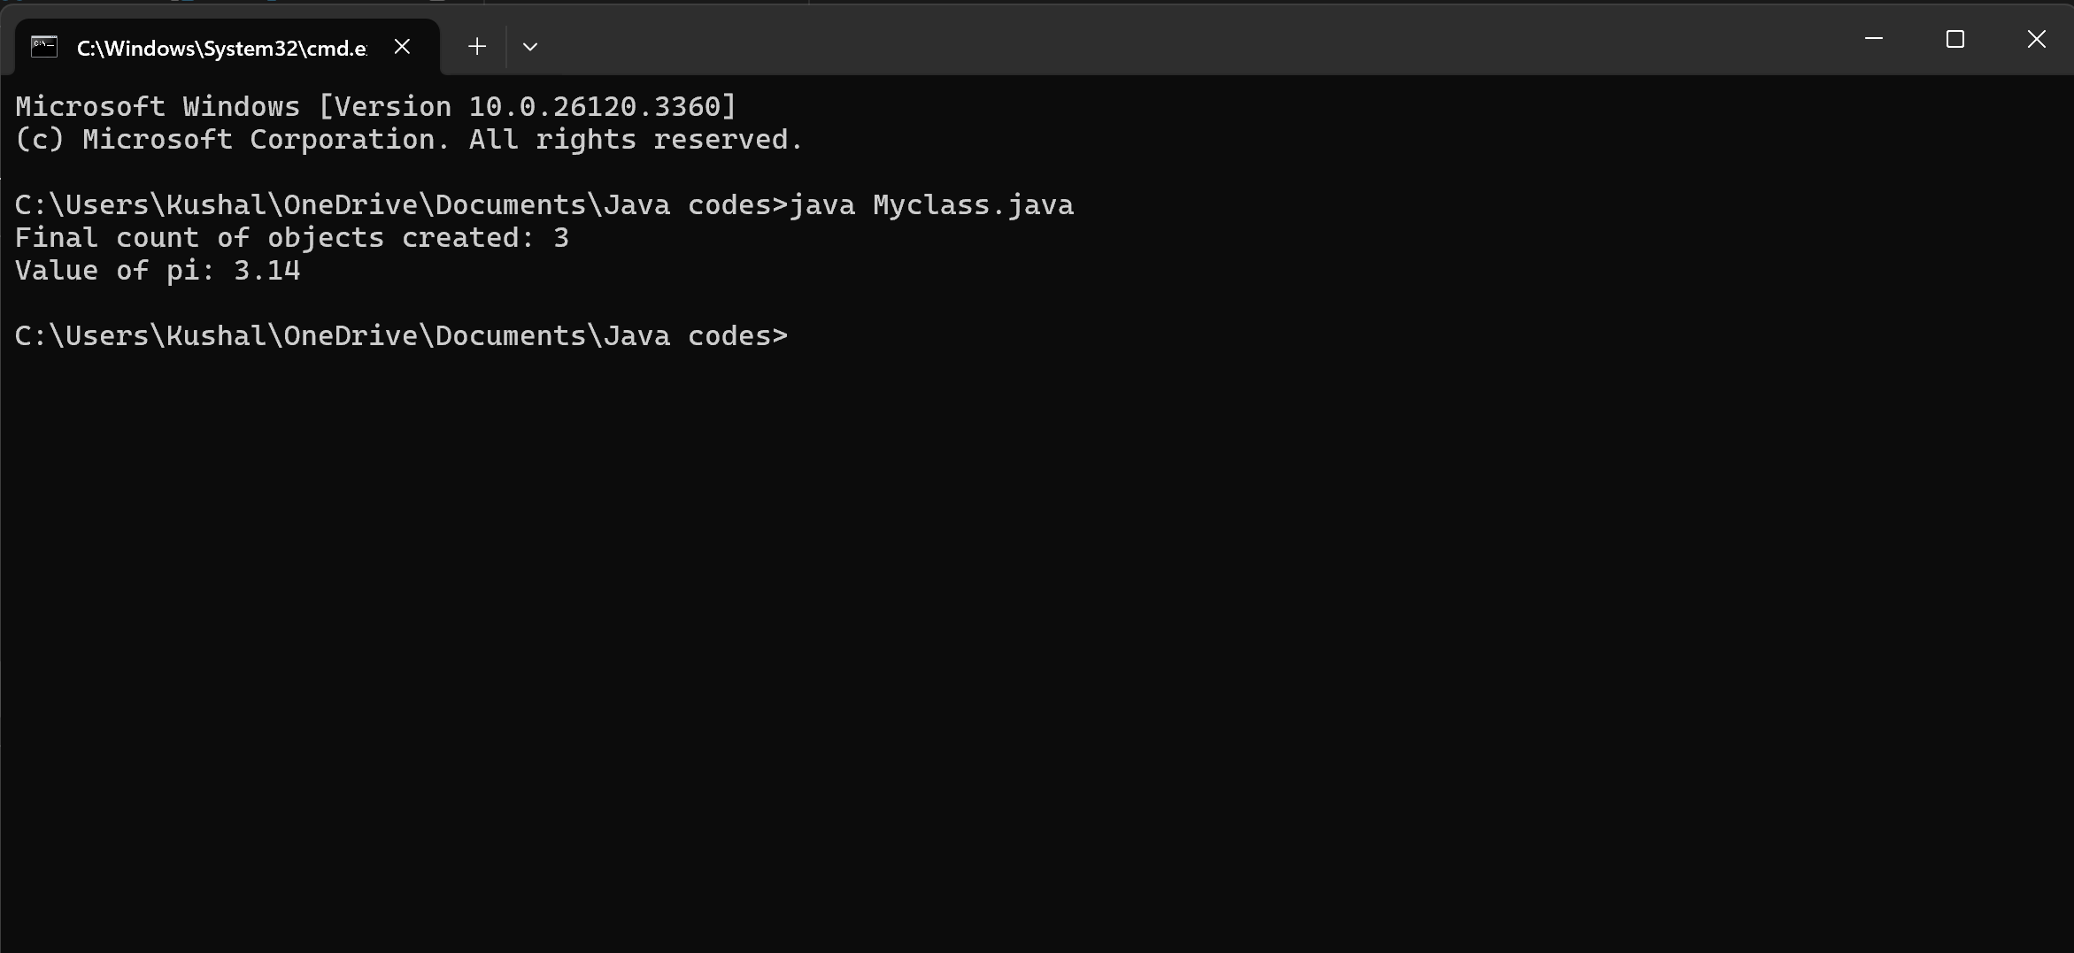

**Error:**

|  |  |  |
| --- | --- | --- |
| **SI.NO** | **ERROR MESSAGE** | **ERROR RECTIFICATION** |
| 1. |  |  |
| 2. | error: can't find primary (String []) method in class: SimpleInterestCalculator | Should close the string brackets [] |

**Important points:**